Discussion #1: Illustrate Islam and China, second to the thirteenth century, and explore religious perspective
Student’s Name
Institution
Course
Professor’s Name
Date

Discussion #1: Illustrate Islam and China, second to the thirteenth century, and explore religious perspective
Art has been a significant part of China and even the spread of Islam in the region in the early 742 CE seems to have appreciated that art was a great part of this culture. For example, the first Mosque, The Great Mosque of Xian in China, believed to be the oldest and constructed in 742CE adopted the art features of the Chinese architect. The mosque’s construction used the form of architecture used to construct a Buddhist temple (as shown below).
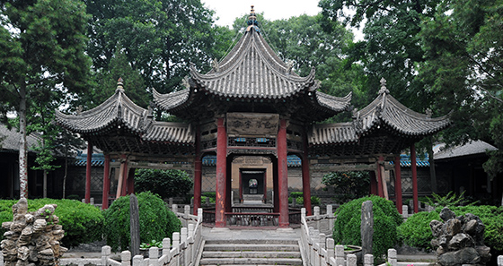
The Great Mosque of Xian, China (Source: Google.com)
As Park (2012) explains, Islamic art is classified as non-monolithic art because for more than 1,300 years Islam spread across the world, it never considered Islamic Art as it is known today. The Islamic empires had great influence in Europe and Asia at different points in history, but they never considered art significant and never identified art with religion. Most of the early artists from the Islamic world defined their arts in terms of region and not with religion (Park, 2012).
Art in the Islamic world is considered aniconic, which means that art does not present humans or animals. As Park (2012) explains, this is just a misconception held about art in the Islamic world. Even though art has been part of China for centuries, art in the Islamic world has lagged behind and it is until the 19th century that the Islamic world started understanding art as part of religion. However, this does not mean that art did not exist in this world in the 13th century or before. Some of the greatest artworks including Islamic architecture and Arabic Calligraphy existed centuries before Islam spread to the rest of the world. But, as mentioned earlier, these artworks were identified only by region such as Syrian or Damascan art, and not Islamic art.

Reference
Park, H. (2012). Mapping the Chinese and Islamic worlds: cross-cultural exchange in pre-modern Asia. Cambridge University Press.

